Vaughan, Barry (from Linked In)
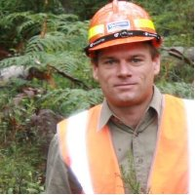

B.Sc. (Forestry) ANU 1990-1993. Master of Business Administration (MBA) 1999 – 2000. Graduate Diploma Bioenergy Linnaeus University 2011.

Gerente Tecnico Forestacion Forestadora Tapebicua 1996 – 1998 Corrientes, Argentina. Implement genetics trails and selection, propagation techniques, forest information system. Business Development Manager VicForests 2011 –2012. Investment Manager Forestry GMO Renewable Resouces Uruguay February 2012 – . Forest acquisitions and contract management.

